Trace Evidence: Glass

1. Glass Introduction
   1. = a _____________________________________ type of trace evidence
   2. _______________________________ of glass
      1. Common material in our ______________________________
      2. Found in many ____________, sizes, __________________, and types
      3. Composed of fused ______________________ material
         * Mixture of:
           + _____________
           + _____________
           + _____________
           + Other trace elements
      4. Variation in ___________ formulas can alter significantly its characteristic _____
      5. Additives’ responsibilities
         1. Alumina (________________)
            * Aluminum oxide
            * Improves chemical ________________ and ________________
         2. Boron Oxide (_______________)
            * Addition used in borosilicate & aluminoborosilicate glasses.
            * Very ________________ ____________________
         3. Lime (________________)
            * Added to improve ______________ & chemical _____________
2. Lead oxide (____________)
   * + - * High lead content lowers ______________ = _______________ hardness, but _____________refractive index
3. _________________ of Glass
   1. Aluminosilicate & borosilicate
      * Can ___________ _________ temps.
   2. Laminated glass
      * Glass w________________________ - used in car ________________________
   3. ___________ glass
      * Fine crystal
   4. Soda lime glass
      * ____________& ___________ glass, glass containers, electric _____________ _______, art objects
   5. ___________________ (stressed) glass
      * Side & back windows of cars; breaks into ____________
4. Glass as Evidence
5. Physical—________________
   1. Can be used to ____________people at a crime scene and _______________ sequence of events
      * Does this make glass CLASS or INDIVIDUAL evidence???
        + Can be used to reconstruct events
        + ____________________
        + Blood
   * Glass is slightly _________________________
     + - When it reaches its ______________ ___________ = _______________
       - this leads to _______________________
       - 2 Distinct types of fractures

1. _______________

2. _______________

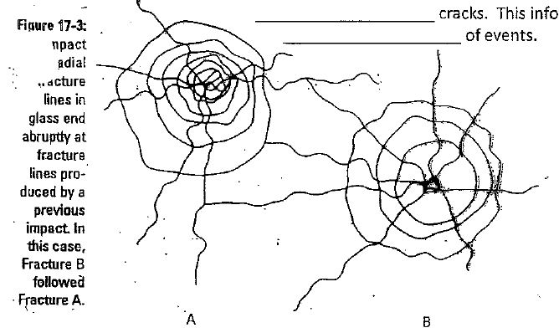Key = ______________ cracks will ____________________when they hit ____________________ cracks. This info can help determine _______________________ of events.

* Direction of Impact
  + Found from ___________marks on the ______________ of broken glass.
  + 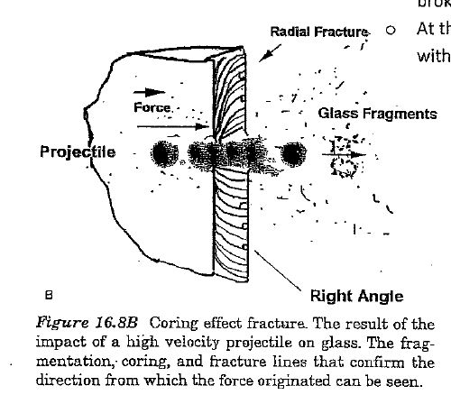At the ______________ of _______________,

glass will break with a ________________

pattern (shell-like)

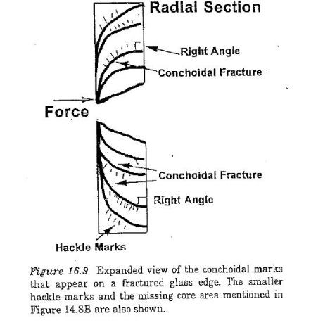

1. Density determination =
2. Refractive index (____) determination
   1. Background:
3. **Refraction** = the ____________ of a ____________wave as it passes from one ____________ to another
4. **Refractive Index (RI)**= a ____________ of the speed of ____________ in a vacuum to the speed of light in ____________substance
   * + **Sample calculation**: speed of light in vacuum is 3.00 x 1010 and the speed of light in water is 2.25 x 1010
     + Thus RI of water =

* 1. Determining the RI from samples in an investigation:

1. Different types of ____________will have ____________ ____
2. To analyze this property🡪

Glass fragments can be ____________ in a liquid with a ____________refractive index to help ____________ the RI of the ____________

* + - 1. Analysis method 1

|  |  |
| --- | --- |
| **Liquid** | **Refractive index** |
| Ethyl acetate | 1.373 |
| n-butyl alcohol | 1.402 |
| Olive oil | 1.467 |
| Corn oil | 1.473 |
| Castor oil | 1.482 |
| Methyl salicylate | 1.522 |
| Clove oil | 1.543 |
| Canola oil | 1.465-1.467 |

--If the liquid has the ____________RI as the glass sample, the glass will ____________ under a microscope.

--If the liquid has a ____________ or ____________RI, the glass is visible and a ____________ appears around perimeter (we call this halo the ________________________).

. . . when RIs are the ____________, the Becke line ____________

. . . if Becke line appears on the __________perimeter = Glass has _____

. . . if Becke line appears on ___________ perimeter = Glass has ______

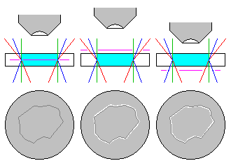

* + - 1. Analysis method 2
* RI is dependant on:
  + The ____________of light
  + The ____________of the medium
  + When the temp. of a liquid is changed, the RI changes rapidly, but the RI of an immersed solid will not
* ____________usually used
* Oil ____________so RI can be determined from its temp.
* Sample glass is immersed in oil
* Oil is ___________________ to determine match temp.
  + - Glass ____________
    - Oil RI = Glass RI

1. Chemical Tests

* ____________
* Test for silicates, metal oxides, trace evidence